**Report on Recuva/CCleaner**

*By*

**Mehnaz Afrose**

**Question 1: what did I do?**

At the very beginning of this assignment, I searched online about the software Recuva. Sometimes we accidentally delete files from computers, memory cards, or external drives and later we often need to recover them. Recuva can be significantly useful software to recover deleted files from the device ([Wikipedia](https://en.wikipedia.org/wiki/Recuva)). Recuva first scans the device, finds the deleted files (i.e., documents, photos, etc.), and when the user selects any file from that list, recuva retrieves the file ([Recuva Review 2023: What is Recuva? Is Recuva Safe or Free?](https://www.cisdem.com/resource/recuva-review.html)).

Before deleting and restoring any file, we should know how hard the drive works to store any file, what does the delete function do? When we try to save any file into the drive, the drive stores the file by using magnets on spinning disks. The file data is saved as the combination of binary codes (0 and 1). The internal system of the drive organizes these spots to keep files organized. To read the file, the drive selects the correct magnetic spots and translates them back to the data so that the computer can understand ([How a Hard Drive Works](https://cs.stanford.edu/people/nick/how-hard-drive-works/#:~:text=The%20hard%20drive%20contains%20a,the%20stored%200's%20and%201's)). When we delete any file from the drive, it empties the spot but does not destroy it and reassigns it so new files can be assigned later ([Can you completely wipe a hard drive?](https://www.avast.com/c-wipe-old-hard-drive#:~:text=Deleting%20files%20from%20a%20hard,to%20actually%20erase%20the%20data.)). That is why deep restoration is possible. But if we occupy the spots by reoccupying with any other data noise, only then the previous file cannot be restored again ([Do moved files leave a trace on the drive they created on?](https://security.stackexchange.com/questions/155967/do-moved-files-leave-a-trace-on-the-drive-they-created-on)) ([At what point is deleted data irrecoverable?](https://security.stackexchange.com/questions/233201/at-what-point-is-deleted-data-irrecoverable)).

For this assignment I downloaded a file [dilbert_security.gif from](https://wtclass.wtamu.edu/bbcswebdav/pid-2714278-dt-content-rid-51964061_1/xid-51964061_1) the WT class and saved it in a specific sample folder. I deleted the file from the folder, went to the recycle bin, found it, and restored the file from the recycle bin. After restoring the file, I opened it, and it opened perfectly.

Then I installed Recuva free version to use. Once installed, I searched on the internet how to use Recuva software. Watched this video [How to Recover Accidentally Deleted Files Using Recuva in 2021](https://www.youtube.com/watch?v=DpU3rvyV-dk). Then I again deleted [dilbert_security.gif from](https://wtclass.wtamu.edu/bbcswebdav/pid-2714278-dt-content-rid-51964061_1/xid-51964061_1), went to the recycle bin, selected the file, and permanently deleted it. Then I used Recuva to restore this deleted file. Recuva recovers files by scanning storage devices for deleted data and reconstructing it from fragments that have not been overwritten ([Research On File Recovery: The Science Behind Retrieving Your Lost Files](https://www.systweak.com/blogs/research-on-file-recovery/)).

At the last step, I installed the CCleaner professional trial version. This is a utility software developed by Piriform, designed to optimize and clean up computers. CCleaner permanently deletes files by overwriting the data multiple times, making it unrecoverable and by removing temporary files, junk data, cookies, and unused entries from the Windows registry, it improves system performance and free up disk space ([CCleaner Malware](https://usa.kaspersky.com/resource-center/threats/ccleaner-malware)). I used this tool to clean up the recycle bin of my computer.

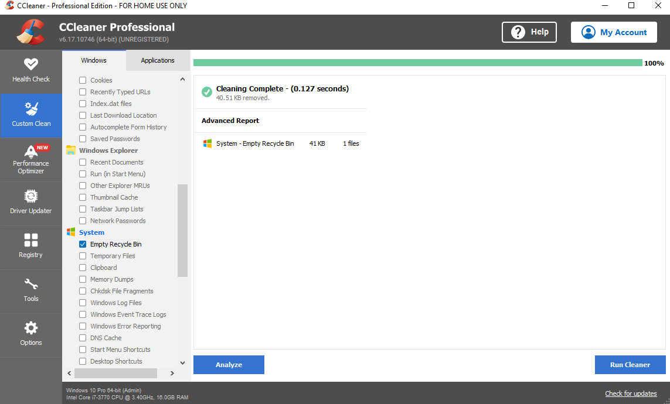

*Figure 1: CCleaner for cleaning the recycle bin*

After cleaning everything from the recycle bin, I ran Recuva again to see if it can find and recover dilbert_security.gif.

**Question 2: What were the results?**

After the permanent deletion of dilbert_security.gif from the recycle bin when I ran Recuva, it could not find this file to restore. Although Recuva could not find this file, I installed CCleaner software to learn about it and to know how this tool works. I used CCleaner to clean the recycle bin, and tried to recover that file using Recuva, again (although I knew that it would not be able to). Just to know the entire process better, I did the steps.

**Question 3: what did I learn?**

By completing this assignment, I was able to learn when we save some file in any hard drive, how the drive works to save it, what is the mechanism behind it. How this works in the drive when we delete any file, then want to restore it. If there is any virus, or corrupted files in the device somehow got installed and normally this file cannot be deleted, I can use CCleaner to permanently delete it. I also learnt the mechanism behind it. Although Recuva could not recover dilbert_security.gif from the permanent deletion state, by using Recuva I was able to recover some very touchy and memorable family pictures which were accidentally permanently deleted a long time ago.

References:

1. [Wikipedia](https://en.wikipedia.org/wiki/Recuva)
2. [How a Hard Drive Works](https://cs.stanford.edu/people/nick/how-hard-drive-works/#:~:text=The%20hard%20drive%20contains%20a,the%20stored%200's%20and%201's)
3. [Can you completely wipe a hard drive?](https://www.avast.com/c-wipe-old-hard-drive#:~:text=Deleting%20files%20from%20a%20hard,to%20actually%20erase%20the%20data.)
4. [Do moved files leave a trace on the drive they created on?](https://security.stackexchange.com/questions/155967/do-moved-files-leave-a-trace-on-the-drive-they-created-on)
5. [At what point is deleted data irrecoverable?](https://security.stackexchange.com/questions/233201/at-what-point-is-deleted-data-irrecoverable)
6. [Recuva Review 2023: What is Recuva? Is Recuva Safe or Free?](https://www.cisdem.com/resource/recuva-review.html)
7. [How to Recover Accidentally Deleted Files Using Recuva in 2021](https://www.youtube.com/watch?v=DpU3rvyV-dk)
8. [Research On File Recovery: The Science Behind Retrieving Your Lost Files](https://www.systweak.com/blogs/research-on-file-recovery/)
9. [CCleaner Malware](https://usa.kaspersky.com/resource-center/threats/ccleaner-malware)